Guided Exploration 01: Computing, Accessibility and Creativity

Points: 30
Due Date: See Canvas.
Work will be accepted up to 24 hours after the due date with a 10% penalty. Meaning if you turn it in at 12:01 am of the next day you will be deducted 10% of the total points from your score. If the assignment is more than 24 hours late, it will be a 0.

Purpose: This guided exploration focuses on fostering creativity through computing and developing foundational skills in computational problem-solving. You will brainstorm ideas, design a website, implement a prototype, and iterate based on feedback.

Objectives
- Analyze effects of computation, exploring its influence on science, society, ethics, economics, culture, and communities worldwide. Understand how computation fosters creativity and inclusivity.
- Design and build computational artifacts (web site) that showcase your creativity, technical expertise, and problem-solving abilities.
- Explain the parts of creating a website that is accessible
- Utilize version control and remote repository using git and github

Effort: Collaborative and Individual following CS Academic Integrity and AI Policy - Harding

- You are encouraged to collaborate to discuss concepts but individually write your own code and answer the questions in your own words . When you ask questions and explain to others you get a deeper understanding. You can use AI tools but remember
  - Acceptable: Using ChatGPT to explain HTML
  - Unacceptable: Asking ChatGPT to generate your explanation

Deliverables: Upload this document as a pdf or word document with your answers

Part 1: Learning, Computing Impact, Collaboration and Careers
1.1 Learning How to Learn
1.2 Learning Computer Science, Academic Integrity and AI Tools
1.3 Working on Teams
1.4 Impact of Computing
1.5 Career Paths Associated with Computer Science
2 Explore and Analyze
2.1 HTML BASICS
2.2 CSS BASICS
2.3 Web Accessibility
2.4 Bootstrap and Responsive Web Design
2.5 Git and Github
3 Reflection

Criterion | Exemplary A+ | Proficient A-B | Developing C-D | Insufficient F
Explore and Explain Concepts  10pts | Clearly explains key ideas with detailed examples, using accurate words from lectures, books, or provided resources. Demonstrates the ability to connect different ideas. | Explains most key ideas with examples and evidence, but some details or examples may be missing. | Explains some ideas but is not clear or complete. Provides limited examples. | Fails to explain key ideas, or explanations are incomplete and lack examples.
Analyze and Apply  10pts | Uses computing concepts to solve problems correctly, showing a strong connection between ideas and practice. | Uses computing concepts correctly, with small mistakes or missing minor details. Solutions show an understanding of ideas and practice. | Tries to use computing concepts, but there are major mistakes or missing steps. | Does not use computing concepts correctly, or the work is not complete.
Reflection  5pts | Response demonstrates in-depth personal reflection on the experience and learnings that includes plans for future action. | Response demonstrates a general reflection on the experience and learnings that includes plans for future action | Response shows little evidence of personal reflection and future action. | Limited evidence, incomplete or missing.

Part 1: Learning, Computing Impact, Collaboration and Careers
The reality of computer science is that there are so many languages, technologies and methodologies available and it is constantly evolving with new ones.

1.1 Learning How to Learn
Learning how to learn is an important component of this course as your career will be full of learning something new. One of my favorite websites is Train Ugly - How To Get More Out Of Your Practice.

I have selected the following podcast for you to listen Desirable Difficulties - The Learner Lab
1.1.1 Explain desirable difficulties and how you think it relates to the learning in this class and in your future career.
Desirable difficulties are effective things that slow down and make it harder to learn something in the current performance, but it pays off by enhancing learning in the long-term run. I think this relates to the learning in this class by going through difficult projects and actually performing the harder things that will later on make it easier for you to retain and learn the concepts and knowledge. In my future career, desirable difficulties can relate to how cybersecurity technologies and tools are constantly evolving and so this level of difficulty in constantly learning something new can enhance learning later on.
1.1.2 Explain the difference between learning and performing
Performing is what you’re doing and seeing now and learning is essentially how well the knowledge is being retained. Performance can be a misleading guide to how well you’re learning, you may feel like you’re learning but that’s not always the case unfortunately.
1.1.3 Summarize three strategies you could incorporate in your learning to help you learn different languages, technologies and methodologies.
Some strategies I could incorporate to make my learning as optimal as possible is spacing, inter-leaving (variation), and studying to teach. Spacing allows you to incorporate a desirable difficulty by dispersing whatever you’re doing into separate sessions whether it’s studying, or shooting freethrows in basketball. It essentially interrupts auto-pilot and restricts you from slipping into it. Another strategy is inter-leaving which introduces variation in your practice by introducing new or different ways to do something rather than your traditional methods. Finally, studying to teach, which is my favorite, is essentially approaching the material in hopes of you teaching it to someone else. If you can teach it, then most likely you were completely engaged in the material.

1.2 Learning Computer Science, Academic Integrity and AI Tools
Read
- 9 Practical Uses of ChatGPT in Programming
- Companies Banning AI Platforms Like ChatGPT in 2023
- Include resources for example for ChatGPT

1.2.1 Explain how AI such as chatgpt can be used to help you learn.
AI such as ChatGPT can be used to help me learn by providing me with explanations that are more tailored to my experience and level of knowledge, creating a personalized learning path or study guide I can effectively follow, and also by giving me adaptive feedback on anything I want feedback on. All these things can boost my learning in a healthy way, while not crossing that line of letting it take hold and doing all the work for me.
1.2.2 Explain how AI such as chatgpt can be used that would hinder your learning.
Piggybacking off of my last answer, using AI such as ChatGPT can really hinder my learning if used incorrectly. Of course the worst thing I can think of is essentially asking the AI to do all the work for you, and you taking credit for it. Not only are you not learning anything but you’re pretty much plagiarizing. This is something you really want to avoid if your goal is to genuinely learn the concepts and process of something .
1.1.4 What do you think is meant by not blindly copying and pasting code and explanation from websites such as stack overflow or AI tools such as chatgpt?
I think it means that AI cannot always be trusted to provide you the correct information and code at times. I think that it’s still developing and constantly getting tweaked so it’s not perfect and won’t always give you correct code every time. There’s a risk of something whether it’s major or minor in the code being an output of machine error on the AI’s part itself.
1.2.3 Use an A.I. tool Ask https://copilot.microsoft.com/ and https://chatgpt.com/ and https://gemini.google.com/
- Describe making a website using HTML and CSS
- Provide me with free online resources to learn more?
- Ask any other questions you are curious about or want to understand more.

Summarize making a website using HTML and CSS. Document your use of the AI tool as a resource as stated in CS Academic Integrity and AI Policy - Harding.docx
Making a website with HTML and CSS is like building a house and then decorating it. HTML is like the blueprint, laying out the foundation and structure – the rooms, walls, and windows. CSS is like the interior designer, choosing the colors, furniture, and how everything looks and feels. You use HTML to create the content and structure, and CSS to make it visually appealing and user-friendly. I specifically used https://gemini.google.com/ to help me summarize and understand more fully of the information above.

1.3 Working on Teams

Interpersonal Skills for Tech Careers & Examples

1.3.1 Give one tip from each section to help you communicate and collaborate with your team this semester. Put answers below.
Become a successful collaborator
Get more comfortable with showing your work and getting feedback from your team while it’s in progress, instead of waiting to finish it and then show it. This allows for more chemistry and productive feedback from your team.
Communicate to pre-empt conflict
It’s better to communicate and get more context into something rather than assuming your teammates already know it will happen. This gives chances for questions and a better understanding between your teammates.
Remember that you’re all on the same team
Being able to see the bigger picture and understand that you’re all working towards a better solution to something is always a good reminder to keep in mind as this can drift off sometimes and create conflict.
Practice active listening
Active listening can help you not only interpret spoken communication more effectively, but also help you understand the unspoken communication in people’s thoughts and feelings.

1.4 Impact of Computing

Read Why is computer science important?

1.4.1 Describe a computing artifact you use that has a positive impact on you.
Trial tenants of the identity and access management solution platforms have been a huge resource to me in terms of getting that practical hands-on experience for certifications I study for and gaining overall knowledge about the platforms.
1.4.2 Describe a computing artifact you use that has both a positive and negative impact on you.
When I used AI such as Gemini or ChatGPT, I feel like the majority of the ways I utilize it can be positive to an extend, but if I’m not aware of what I’m trying to use it for sometimes, I can utilize it in a negative way that impedes my optimal learning process.

1.5 Career Paths Associated with Computer Science

Learn about different careers associated with computer science.

Pick at least 5 resources below to learn about different careers related to technology or add your own resources.

Career Resources - Complete at least 5 | 1.5.1 Share what interested you about the job or why you may not be interested.
Cloud Computing Careers | Cloud Security Engineer pops out to me because it’s fascinating how there're so many security vectors an organization needs to harden in terms of security in the cloud nowadays. Personally, an identity and access management administrator in the cloud takes on the responsibility of securing all sorts of identities in your organization as threat actors love using compromised credentials to infiltrate companies.
7 Machine Learning & Generative AI Jobs | AI Engineers who build all the chatbots and smart assistants with natural processing languages are definitely going to be in high demand in the near future as AI takes off in recent years, and especially as other countries like China want to compete in the industry. It seems interesting as a job that comes with security.
6 In-Demand Cybersecurity Careers | Information Security Analyst, perhaps more specifically a Security Operations Center Analyst seems intriguing as you’re on the frontlines of your company constantly analyzing logs and different systems using all sorts of tools like EDR and SIEMs to look for threat actors and signs of compromise in your work environment sounds exciting and fun.
Brina Software Engineer at Instagram
Niesha Davis Aerospace Engineer at NASA
Tess Software Security Engineer at Google
Fredrico Microsoft Software engineer Working on Images for National Center of Missing Children
Jerome Morrison Design Technologist at Meow Wolf
Christopher Lopez Security Analyst at Tanium | As Chris said himself, he is basically a computer detective in search of clues to better build the pieces of context that can tell you the bigger picture of what’s actually happening. Using a variety of tools, all these bits of “clues” that these tools can give you allows you to find the hackers in a timely manner and remediate the incident that can occur. This to me is really fascinating and exciting.
Danelle Cline Software Engineer at MBARI Studying of the Deep Ocean
Polina Guskova Machine Learning Data Scientist at Electronic Arts
Kinsley Software Engineer at Facebook
Brina Software Engineer at Instagram Android App
4 Careers for People with Coding Backgrounds: Individual Contributor, Management, Training, Sales
Identity And Access Management Analyst Job Description | Zluri | An IAM Analyst’s duties essentially revolves around managing and securing all the internal and external identities of your organization. These include not only users as identities, but also devices, service principals, and other companies that you might be collaborating with. You’re setting up the landscape of how identity lifecycle is managed, and how those identities require different types of permissions and privileges to do their jobs, while adhering to principle of Zero Trust and least privilege (giving people the permission to do what they only intend to do, nothing less and nothing more).
Put link to your resource
Put link to your resource
Put link to your resource

Explore the following MSU Denver Technology Related Majors
- Computer Science Major, B.S. - MSU Denver
- Data Science and Machine Learning - MSU Denver
- Computer Engineering Major, B.S. - MSU Denver
- Bachelor of Science in Cybersecurity - MSU Denver
- Computer Information Systems Major, B.S. - MSU Denver
- Electrical Engineering Technology Major, B.S. - MSU Denver
- Mechanical Engineering Technology Major, B.S. - MSU Denver
- Technical Writing and Editing Major, B.S. - MSU Denver

1.5.2 Share one major you are interested in or pick Other MSU majors. Explain why you are interested in that major.
Not only am I interested in a B.S. in Cybersecurity at MSU Denver, I’m actually pursuing this major right now in hopes of breaking into the cybersecurity sector. As someone who’s building a foundation in information technology as a Tier 1 Systems Technician at an energy company right now, I believe utilizing this experience on top of a quality education at MSU could set me up with many opportunities to find my certain niche of interest in the Cybersecurity industry.

2 Explore and Analyze
In this section you will explore using HTML, CSS and Bootstrap to design an accessible web page of your resume. Write your own response. Do not use A.I. or copy and paste work as your answers.

EXPLAIN - Explain using supporting evidence - words, examples, diagrams.

2.1 HTML BASICS
- Go through the tutorials HTML Elements, HTML List Examples, HTML Links Hyperlinks, HTML Images,HTML Tables, HTML Comments exploring the 
- Create a webpage, using the HTML Online Editor, that is a draft of a technical resume for you. The webpage doesn’t save so copy and paste the HTML document below. Include the following in your webpage where you can just copy and paste the html structures and then fill in the content for the structures:
- Heading of your Resume Header
- Paragraph containing Resume Summary
- Sub heading labeled “Soft Skills”
  - A list list of special soft skills
- Sub heading labeled “Education”
  - Include Education on Your Resume
    - Name of the institution
    - Degree as a link. If you do not have one established just pick one you might consider. Here is a page that has 2 of the computer science degrees. Department of Computer Sciences - MSU Denver
    - School location
- An image that is not copyrighted. For example you can search https://pixabay.com/ or create your own.
- Include a comment in your code that explains what comments are.
2.1.1 Copy and paste your HTML below.

<!DOCTYPE html>
<html>
<body>

<h1>Baht Otgonbayar </h1>
<h2>(720) 427-1794 <a href="https://www.linkedin.com/in/botgonbayar/">LinkedIn</a> </h2>
<p>As a cybersecurity professional pursuing a Bachelor of Science in Cybersecurity, I specialize in Identity and Access Management (IAM) and innovative security solutions. Currently serving as a Systems Technician for a leading organization in the U.S. energy sector, I bring hands-on expertise in managing Azure environments, implementing advanced security protocols, and optimizing IAM strategies to strengthen organizational defenses.

With a passion for continuous learning and a proactive approach to the ever-evolving cyber landscape, I am dedicated to designing and advancing robust IAM frameworks and scalable security solutions for cloud and hybrid environments.</p>

<h3>Soft Skills</h3>

<ul>
<li>Communication</li>
<li>Teamwork</li>
<li>Problem-solver</li>
</ul>

<h3>Education</h3>

<ul>
<li>Metropolitan State University of Denver</li>
<li><a href="https://catalog.msudenver.edu/preview_program.php?catoid=48&poid=12014">Cybersecurity B.S.</a></li>
<li>890 Auraria Pkwy, Denver, CO 80204</li>
</ul>

<h2>HTML Image</h2>
<img src="https://pixabay.com/photos/ai-digital-art-ai-art-cyber-8420370/" alt="Cybersecurity">

<!-- This is a comment -->
<p>With comments you can place notifications and reminders in your HTML code.</p>
<!-- Comments are not displayed in the browser -->

</body>
</html>

https://glitch.com/edit/#!/1030-test-project-?path=index.html%3A1%3A0

2.1.2 Explain the basics of html tags and attributes in your own words and include examples from your HTML above. This can be screenshots or copying and pasting code. You can also include comments in the html to explain.
HTML tags are basically how you identify which elements are being used and the attributes of that specific element can have different use cases for it. An example of a tag is <img and the attribute of this tag is “src” in this, meaning the source of this certain element should be some type of link or file: <img src="https://pixabay.com/photos/ai-digital-art-ai-art-cyber-8420370/”

2.2 CSS BASICS

- Read and explore the following.
- CSS Introduction
- HTML div tag and HTML class Attribute to incorporate CSS styling
- CSS Background Color
- CSS Borders
- CSS Text Alignment and Text Direction
- CSS Styling Lists
- CSS Icons
- W3Schools Tryit Editor - CSS Buttons
- CSS Comments

- Add styles to your html from part 1 above using class selectors. You can use the W3Schools Tryit Editor. Include the following
  - Create a div tag and a class to style the web page with a background color.
  - Create a class to style the resume heading so the text is center aligned.
  - Create a div tag and class to add a border around each section for soft skills and education section
  - Add a button “Show Projects” at the bottom of the webpage
  - Explore other CSS styling and add at least 2 more items
  - Add comment describing class div tag and class attributes

2.2.1 Copy and paste html document with above styling below.

<!DOCTYPE html>
<html>
<head>
<style>
/* Background color style */
body {
background-color: lightgreen;
font-family: Arial, sans-serif; /* Improves readability */
margin: 0;
padding: 20px;
}

/* Centered header style */
.background-color-header {
text-align: center;
padding: 10px;
}

/* Border style */
.border-skills {
border: 5px outset red;
background-color: white;
margin: 15px;
padding: 15px;
}

/* Button Style */
.button-container {
text-align: center;
margin-top: 20px;
}

.button {
background-color: darkgreen;
color: white;
padding: 12px 25px;
font-size: 16px;
border: none;
cursor: pointer;
border-radius: 8px;
}

}
</style>
</head>
<body>

<!-- Header -->
<div class="background-color-header">
<h1>Baht Otgonbayar</h1>
<h2>(720) 427-1794 <a href="https://www.linkedin.com/in/botgonbayar/">LinkedIn</a></h2>
</div>

<!-- Summary -->
<p>As a cybersecurity professional pursuing a Bachelor of Science in Cybersecurity, I specialize in Identity and Access Management (IAM) and innovative security solutions. Currently serving as a Systems Technician for a leading organization in the U.S. energy sector, I bring hands-on expertise in managing Azure environments, implementing advanced security protocols, and optimizing IAM strategies to strengthen organizational defenses.</p>

<p>With a passion for continuous learning and a proactive approach to the ever-evolving cyber landscape, I am dedicated to designing and advancing robust IAM frameworks and scalable security solutions for cloud and hybrid environments.</p>

<!-- Soft Skills Section -->
<div class="border-skills">
<h3>Soft Skills</h3>
<ul>
<li>Communication</li>
<li>Teamwork</li>
<li>Problem-solving</li>
<li>Adaptability</li>
<li>Critical Thinking</li>
</ul>
</div>

<!-- Education Section -->
<div class="border-skills">
<h3>Education</h3>
<ul>
<li>Metropolitan State University of Denver</li>
<li><a href="https://catalog.msudenver.edu/preview_program.php?catoid=48&poid=12014">Cybersecurity B.S.</a></li>
<li>890 Auraria Pkwy, Denver, CO 80204</li>
</ul>
</div>

<!-- Certifications Section -->
<div class="border-skills">
<h3>Certifications</h3>
<ul>
<li>CompTIA Security+</li>
<li>Microsoft Certified: Identity and Access Administrator Associate (SC-300)</li>
<li>Okta Certified Professional</li>
</ul>
</div>

<!-- Technical Skills Section -->
<div class="border-skills">
<h3>Technical Skills</h3>
<ul>
<li>Identity & Access Management (IAM)</li>
<li>Azure Active Directory (Entra ID)</li>
<li>Privileged Access Management (PAM)</li>
<li>BeyondTrust & Okta</li>
<li>Network Security & VPNs</li>
</ul>
</div>

<!-- Github button at the bottom -->
<div class="button-container">
<a href="https://github.com/botgonbayar?tab=repositories" class="button">Github</a>
</div>

</body>
</html>
2.2.2 Take a screenshot of how the html with css is displayed and paste it below.
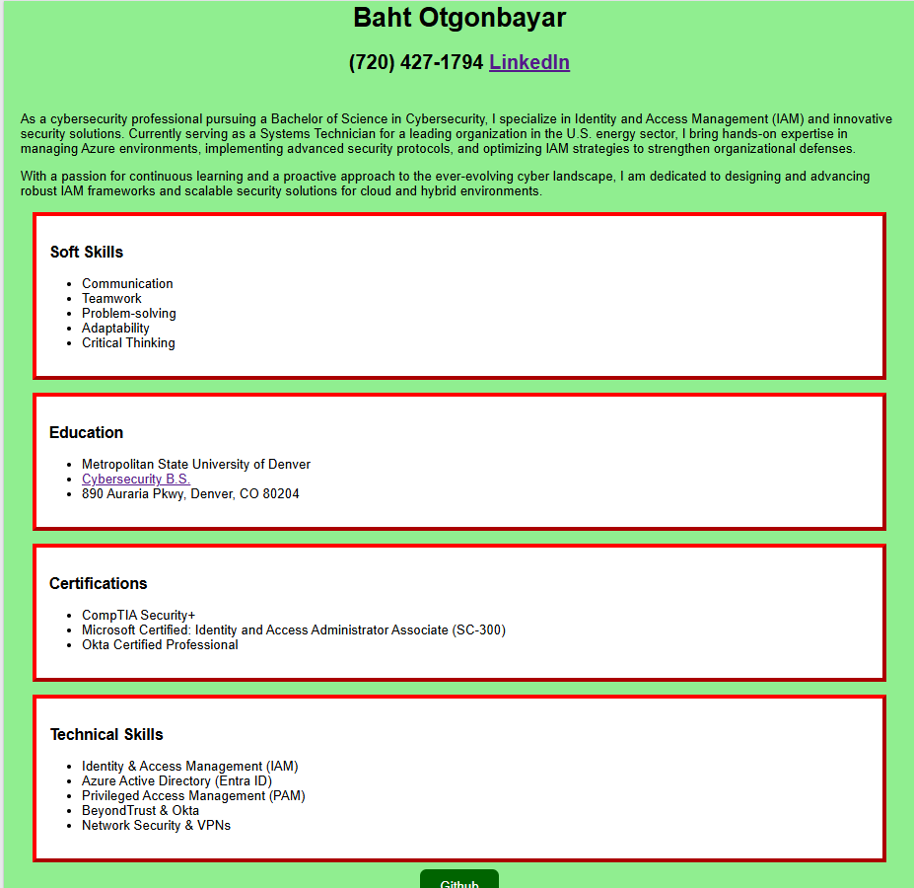
2.2.3 Explain the basics of CSS. Explain div tags and class selectors. Include examples from your code in your explanations. This can be screenshots or copying and pasting code. You can also include comments in the html to explain.
CSS essentially allows you to style HTML elements so you can make your website however you want it to look by controlling colors, layouts, fonts, and spacing. One of the key things in CSS is using div tags and class selectors to organize and style content. A div is like a container that groups elements together so you can style them easily. An example of a div from my resume site is:
<div class="border-skills">
<h3>Soft Skills</h3>
<ul>
<li>Communication</li>
<li>Teamwork</li>
<li>Problem-solver</li>
</ul>
</div>
Here, the “div” groups the heading and list together. Then if you notice the “class=”border-skills” section, that’s called a class selector specifically here the .border-skills class. The code of this class with some comments to explain some properties is:
.border-skills {
border: 5px outset red; /* Adds a red border */
background-color: lightgreen; /* Sets background color */
margin: 10px; /* Adds space outside the div */
padding: 10px; /* Adds space inside the div */
}

And if you notice the dot (.) before border-skills, it means it’s a class, which can be used on multiple elements. This makes styling more flexible instead of changing each element one by one. So using divs and class selectors basically helps keep things organized and easy to style overall.

2.3 Web Accessibility

2.3.1 autistic spectrum
- Use simple colours
- Build simple and consistent layouts
2.3.2 screen readers
- Describe images and provide transcripts for video
- Follow a linear, logical layout
2.3.3 low vision
- Use appropriate contrasts and a readable font size
- Put buttons and notifications in context
2.3.4 physical or motor disabilities
- Make large clickable actions
- Design for keyboard or speech only use
2.3.5 deaf or hard of hearing
- Use subtitles or provide transcripts for videos
- Write in plain English
2.3.6 Dyslexia
- Use images and diagrams to support text
- Keep content short, clear and simple

2.4 Bootstrap and Responsive Web Design

Bootstrap 5 Get Started

2.4.1 What is responsive Web Design?

Responsive web design is basically making websites that are easily adjustable when viewing them on different types of devices, from small phones to tables to computer desktops.
2.4.2 Explore Bootstrap 5 Containers

What are containers?
Containers are used to pad the content inside of them. Bootstrap requires this containing element to wrap site contents.

Paste code that shows different containers with different borders and colors.
<!DOCTYPE html>
<html lang="en">
<head>
<title>Bootstrap Example</title>
<meta charset="utf-8">
<meta name="viewport" content="width=device-width, initial-scale=1">
<link href="https://cdn.jsdelivr.net/npm/bootstrap@5.3.3/dist/css/bootstrap.min.css" rel="stylesheet">
<script src="https://cdn.jsdelivr.net/npm/bootstrap@5.3.3/dist/js/bootstrap.bundle.min.js"></script>
</head>
<body>

<div class="container p-5 my-5 bg-dark text-white">
<h1>My First Bootstrap Page</h1>
<p>This container has a dark background color and a white text, and some extra padding and margins.</p>
</div>

<div class="container-fluid p-5 my-5 bg-primary text-white">
<h1>My First Bootstrap Page</h1>
<p>This container has a blue background color and a white text, and some extra padding and margins.</p>
</div>

2.4.3 Explore Bootstrap 5 Cards

What can cards be used for?
Cards can be used for a bordered box with some padding around its content. It includes options for headers, footers, content, colors, and more.
Paste code that shows an example of a card.
<!DOCTYPE html>
<html lang="en">
<head>
<title>Bootstrap Example</title>
<meta charset="utf-8">
<meta name="viewport" content="width=device-width, initial-scale=1">
<link href="https://cdn.jsdelivr.net/npm/bootstrap@5.3.3/dist/css/bootstrap.min.css" rel="stylesheet">
<script src="https://cdn.jsdelivr.net/npm/bootstrap@5.3.3/dist/js/bootstrap.bundle.min.js"></script>
</head>
<body>

<div class="container mt-3">
<h2>Basic Card</h2>
<div class="card">
<div class="card-body">Basic card</div>
</div>
</div>
2.4.4 Explore Bootstrap 5 Navigation Bars

Paste code that shows an example of a nav bar.
<!DOCTYPE html>
<html lang="en">
<head>
<title>Bootstrap Example</title>
<meta charset="utf-8">
<meta name="viewport" content="width=device-width, initial-scale=1">
<link href="https://cdn.jsdelivr.net/npm/bootstrap@5.3.3/dist/css/bootstrap.min.css" rel="stylesheet">
<script src="https://cdn.jsdelivr.net/npm/bootstrap@5.3.3/dist/js/bootstrap.bundle.min.js"></script>
</head>
<body>

<nav class="navbar navbar-expand-sm bg-light">
<div class="container-fluid">
<ul class="navbar-nav">
<li class="nav-item">
<a class="nav-link" href="#">Link 1</a>
</li>
<li class="nav-item">
<a class="nav-link" href="#">Link 2</a>
</li>
<li class="nav-item">
<a class="nav-link" href="#">Link 3</a>
</li>
</ul>
</div>
</nav>
2.4.4 Explore another bootstrap Tutorial

Explain what you explored.
I explored bootstrap dark mode. By default, bootstrap pages have a white (light) background color. But If you want to change the whole page to a darker color, you can add data-bs-theme="dark" to the <html> element.

Paste code that shows an example.
<!DOCTYPE html>
<html lang="en">
<head>
<title>Bootstrap Example</title>
<meta charset="utf-8">
<meta name="viewport" content="width=device-width, initial-scale=1">
<link href="https://cdn.jsdelivr.net/npm/bootstrap@5.3.3/dist/css/bootstrap.min.css" rel="stylesheet">
<script src="https://cdn.jsdelivr.net/npm/bootstrap@5.3.3/dist/js/bootstrap.bundle.min.js"></script>
</head>
<body>

<div class="container mt-3">
<h2>Dark Mode Table</h2>
<table class="table" data-bs-theme="dark">
<thead>
<tr>
<th>Firstname</th>
<th>Lastname</th>
<th>Email</th>
</tr>
</thead>
<tbody>
<tr>
<td>John</td>
<td>Doe</td>
<td>john@example.com</td>
</tr>
<tr>
<td>Mary</td>
<td>Moe</td>
<td>mary@example.com</td>
</tr>
<tr>
<td>July</td>
<td>Dooley</td>
<td>july@example.com</td>
</tr>
</tbody>
</table>
</div>

2.5 Git and Github

2.5.1 What is version control?
Version control basically keeps track of every change you make to your project (like code, files, or documents), so if something goes wrong, you can go back to an earlier version. It also lets multiple people work on the same project without stepping on each other’s toes.
2.5.1 What is Git?
A version control system that tracks code changes locally. It works offline and saves the version-controls on your local computer.
2.5.1 What is github?
Github is a cloud-based platform where you can store, share and work together with others to write code. Basically enabling remote collaboration with others from anywhere. It does require connection since it’s connected to the cloud.

Put a screenshot of a your repository in github
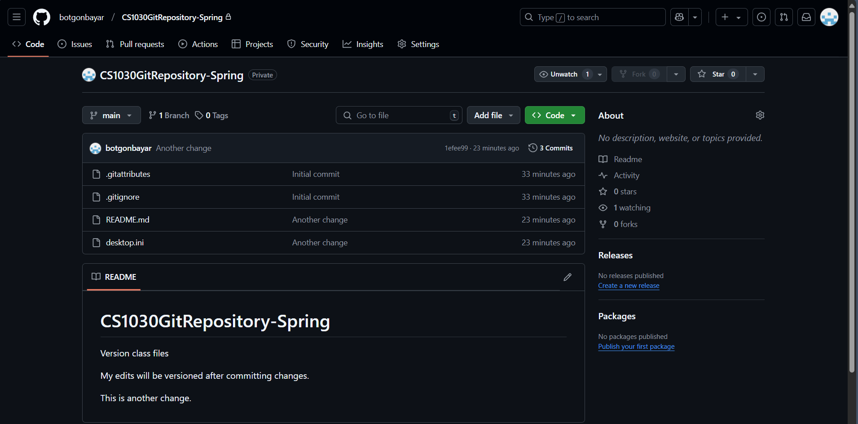

3 Reflection

3.1 Identify one specific challenge you faced in this exploration. How did you address it using the strategies discussed (e.g., desirable difficulties, learning vs. performing)?
One specific challenge I faced in this guided exploration was not only trying to learn the detailed concepts of both HTML and CSS but actually retain the knowledge and coding I wrote so it was important for me to always keep the principle of desirable difficulties in the back of my mind especially using the spacing strategy to leave a gap between learning and studying sessions to allow the new barrage of information to soak in and retain with HTML, CSS, Bootstrap, and more.
3.2 Explain how you ensured the AI usage was used to help your learning and did not hinder your learning for this exploration.
I made sure I utilized AI to help me learn better in a way that didn’t hinder my learning at the same time for this exploration by letting it provide better explanations and examples that allowed me to understand the harder to grasp concepts with better clarity. I used to give me positive criticism and feedback on my code so I can move forward with best practices in mind when coding.
3.3 What was the most challenging part of this exploration, and why?
The most challenging part of this exploration was getting used to the layout and syntax of how HTML and CSS operate together in a structured way and sort of getting used to it in the beginning took some time to understand fully. I think setting up Git and Github was a challenge I enjoyed as well.
3.4 How did you manage your time to complete each section after lectures? What adjustments might help you stay on track in future assignments?
I managed my time to complete each section after lectures by devoting a certain amount of time on a daily basis to actually learning the content then utilizing the information I learned to tackle each section. Some adjustments that might help me to stay on track in future assignments would be along the lines of being more consistent with managing time and utilizing other credible sources to attack the content from other perspectives and angles.

Read what the deliverables are for this assignment and submit them all to canvas. You can submit at different times but pay attention to the due date and the late date.

